ElectroHub Executive Business Intelligence Report

1. Executive Summary
This report presents a data-driven analysis of ElectroHub’s product performance, sales distribution, and profitability using transactional and customer data.
The analysis reveals a business with strong performance concentration in a few high-performing products, alongside significant underperformance across a long tail of low-value items.
Key findings include:
- Apple iPhone 14 dominates performance, contributing:
  - 23.38% of total units sold (281 units)
  - 66.76% of total sales ($22,479,719)
- Significant disparity exists between top and bottom products:
  - Sales range from $22,374 (Colgate Toothpaste) to $22,479,719 (iPhone 14)
- Low-performing products contribute minimal value despite occupying inventory
- Profitability is also concentrated, with top products significantly outperforming others
These findings highlight revenue concentration risk, inefficient product mix, and opportunities for optimization.

2. Product Performance Analysis

2.1 Top Performing Products (Quantity, Sales, Profit)
- Apple iPhone 14
  - Highest Units Sold: 281 units
  - Accounts for 23.38% of total units sold
  - Generates $22,479,719 in sales (66.76% contribution)
- Comparison Benchmark
  - Lowest among top 5 (by quantity): Apple MacBook Air – 225 units
  - iPhone 14 outperforms MacBook Air by 24.89%
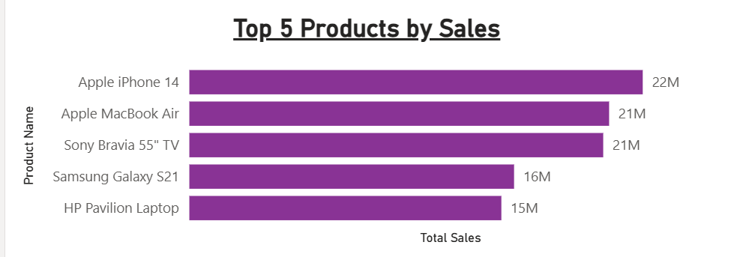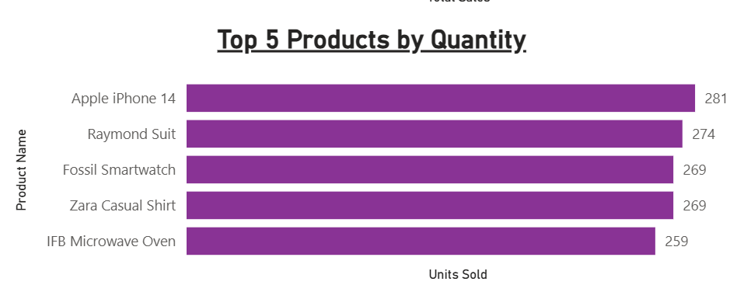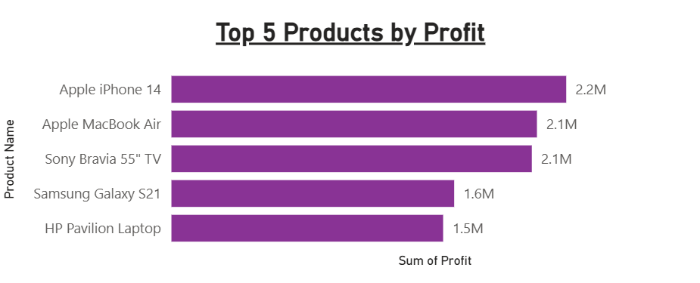
Insight:
A single product (iPhone 14) disproportionately drives both volume and revenue, indicating heavy dependency on flagship products.

2.2 Bottom Performing Products (Sales & Profit)
- Colgate Toothpaste
  - Lowest Sales: $22,374
- Tupperware Lunch Box
  - Highest within bottom group: $279,285
  - Still significantly lower than top-tier products
  - Represents 43.04% of sales within bottom 5

Insight:
There is a massive performance gap (over 1,148%) between products even within the lowest-performing group, indicating inconsistent product value contribution.

2.3 Bottom Performing Products (Quantity / Revenue Efficiency)
- Nivea Body Lotion
  - Lowest contribution: $87,381
- FabIndia Kurta
  - Highest within this segment: $629,790 (36.55% share)
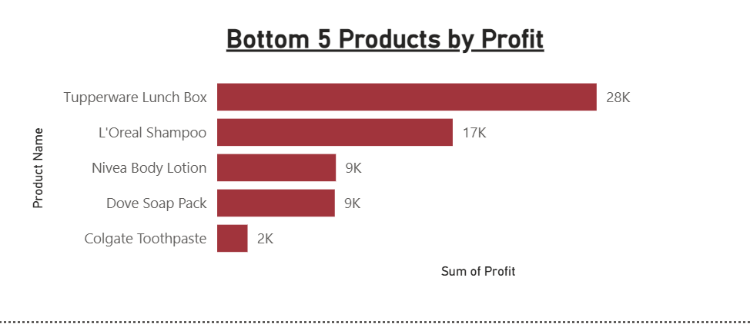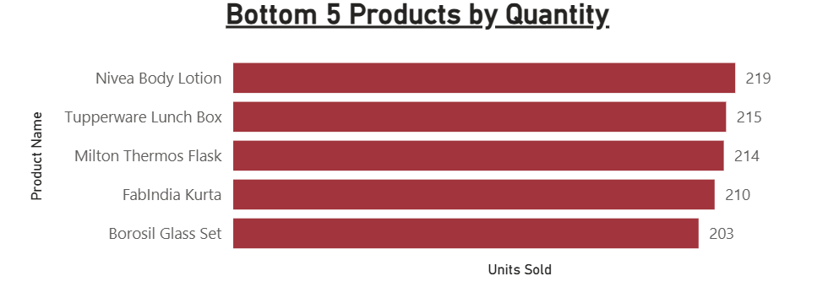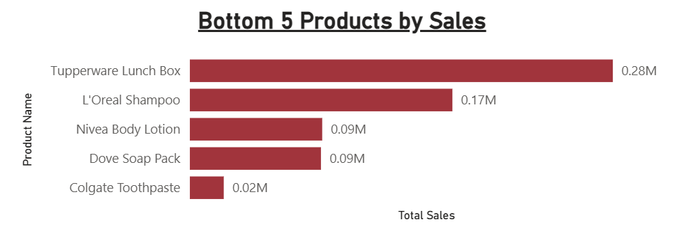
Insight:
Low-performing products show weak demand and inefficient revenue generation relative to inventory presence.

2.4 Profit Performance
- Apple iPhone 14
  - Highest contribution: $22,479,719
  - Accounts for 23.57% of total profit
- HP Pavilion Laptop
  - Lowest among top performers: $15,469,762
  - iPhone 14 outperforms by 45.31%
Insight:
Profit is strongly aligned with high-revenue products, reinforcing the dependency on a limited product set.

3 Sales Trends Over Time (Daily, Monthly, Quarterly, Annually)

Findings
Sales show high volatility across the entire period (2020–2024), with daily values ranging from $0.00M to above $0.65M.
Performance is spike-driven, with sharp increases occurring intermittently rather than consistently. There is no clear upward or downward trend, and revenue is concentrated in specific periods rather than evenly distributed over time.
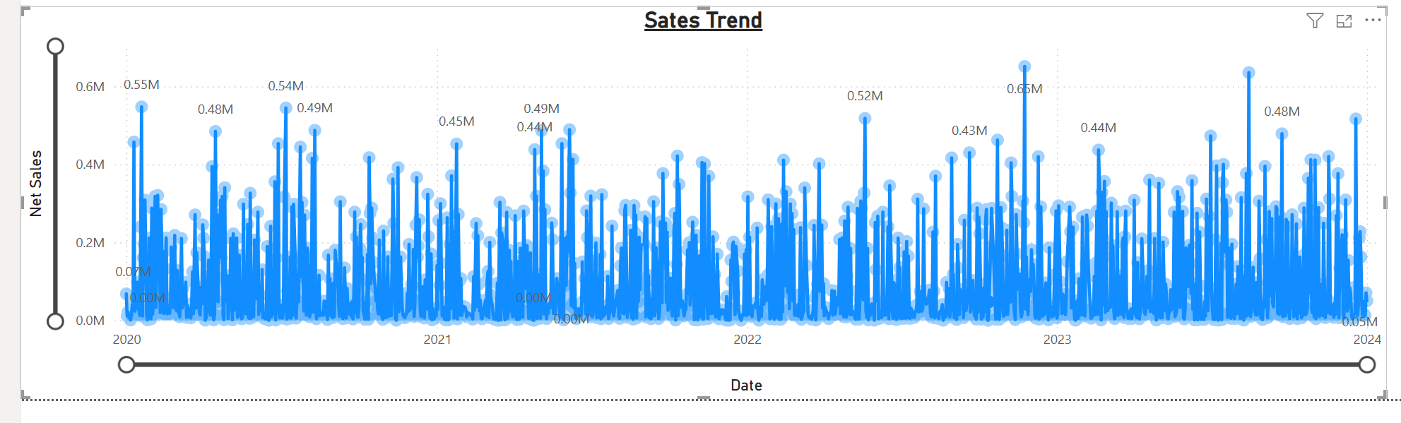

Insight
Sales are irregular and event-driven, indicating inconsistent demand and reliance on isolated high-value transactions.

Recommendation
- Introduce targeted campaigns to stabilize sales across periods
- Align promotions with historically high-performing periods
- Implement strategies to increase consistent daily sales activity

4. Key Business Insights

4.1 Revenue Concentration Risk
- A single product (iPhone 14) contributes 66.76% of total sales
👉 Risk: Business performance is vulnerable to demand or supply disruption of one product

4.2 Product Portfolio Imbalance
- Bottom products contribute negligible revenue (<$300k range)
- Large disparity between product tiers
Risk: Inefficient capital allocation and inventory management

4.3 Profit Concentration
- Profit follows the same pattern as revenue
- Top-tier products significantly outperform mid and low-tier products
Risk: Limited diversification of profit streams

Strategic Recommendations

5.1 Product Portfolio Optimization
- Prioritize high-performing products (Apple iPhone 14) for availability and promotion
- Reduce or bundle low-performing products (e.g., Colgate Toothpaste, Nivea Body Lotion)
- Reallocate resources toward mid-performing products
Expected Impact:
- Improve inventory efficiency
- Reduce capital tied up in low-performing products

5.2 Revenue Diversification Strategy
- Reduce over-dependence on iPhone 14 (66.76% revenue share)
- Promote alternative high-value products such as:
  - HP Pavilion Laptop
  - Apple MacBook Air
Expected Impact:
- Lower revenue concentration risk
- Improve business stability

5.3 Pricing & Bundling Strategy
- Introduce bundling for low-performing items:
  - Example: Accessories + high-demand electronics
- Use pricing strategies to improve movement of low-demand products
Expected Impact:
- Increase average order value
- Improve sales of stagnant inventory

5.4 Profit Optimization
- Focus on scaling products with strong profit performance
- Optimize pricing strategies for mid-tier products to improve margins
Expected Impact:
- Increase overall profitability
- Improve margin consistency across products

6. Conclusion
The analysis demonstrates that ElectroHub’s business is currently driven by a narrow set of high-performing products, with significant inefficiencies in the broader product portfolio.
While flagship products such as the Apple iPhone 14 drive strong revenue and profit, the heavy reliance on a single product and the underperformance of others present material business risks.
Strategic focus on portfolio optimization, revenue diversification, and pricing strategies will enable ElectroHub to achieve more balanced and sustainable growth.

